Application Lifecycle Lab
In this lab, you explore the Application Lifecycle capabilities of Red Hat® Advanced Cluster Management for Kubernetes (RHACM).
Goals
- Understand Application Lifecycle capabilities in RHACM
- Deploy an application to a managed cluster
- Remove a deployed application from a managed cluster
- Change a deployed application (optional)
Prerequisite
- Completion of the Cluster Lifecycle Lab
1. Introduction
In the previous lab, you explored the Cluster Lifecycle functionality in RHACM. This allowed you to add an OpenShift® cluster to RHACM, which you can now use to deploy applications.
1.1. Review Application Lifecycle Functionality
Application Lifecycle functionality in RHACM provides the processes that are used to manage application resources on your managed clusters. This allows you to define a single- or multi-cluster application using Kubernetes specifications, but with additional automation of the deployment and lifecycle management of resources to individual clusters. An application designed to run on a single cluster is straightforward and something you ought to be familiar with from working with OpenShift fundamentals. A multi-cluster application allows you to orchestrate the deployment of these same resources to multiple clusters, based on a set of rules you define for which clusters run the application components.
This table describes the different components that the Application Lifecycle model in RHACM is composed of:
Resource | Purpose
Channel | Defines a place where deployable resources are stored, such as an object store,  Kubernetes namespace, Helm repository, or GitHub repository.
Subscription | Definitions that identify deployable resources available in a Channel resource that  are to be deployed to a target cluster.
PlacementRule | Defines the target clusters where subscriptions deploy and maintain the application.  It is composed of Kubernetes resources identified by the Subscription resource and  pulled from the location defined in the Channel resource.
Application | A way to group the components here into a more easily viewable single resource.  An Application resource typically references a Subscription resource.

These are all Kubernetes custom resources, defined by a Custom Resource Definition (CRD), that are created for you when RHACM is installed. By creating these as Kubernetes native objects, you can interact with them the same way you would with a Pod. For instance, running oc get application retrieves a list of deployed RHACM applications just as oc get pods retrieves a list of deployed Pods.
This may seem like a lot of extra resources to manage in addition to the deployables that actually make up your application. However, they make it possible to automate the composition, placement, and overall control of your applications when you are deploying to many clusters. With a single cluster, it is easy to log in and run oc create -f.... If you need to do that on a dozen clusters, you want to make sure you do not make a mistake or miss a cluster, and you need a way to schedule and orchestrate updates to your applications. Leveraging the Application Lifecycle functionality in RHACM allows you to easily manage multi-cluster applications.
1.2. Consider Personas
When you think about Application Lifecycle features, think about these personas and their needs:
Persona | Need and RHACM Solution
IT Operations | - I want new clusters to be deployed with a set of known configurations and required  applications.  - With the assignment of a label at cluster deploy time, the necessary configurations and  applications are automatically deployed and running without any additional manual effort.
DevOps/SRE | - I want to quickly investigate application relationships with real-time status, so that  I can see where problems are.  - With the Application Topology view, you can visually inspect application status labels  and Pod logs to understand if a part of the application is running or not, without having  to connect to a cluster and gather any information.
2. Create Application in RHACM
Now that you have an idea of what the Application Lifecycle capabilities are in RHACM, it is time to deploy a simple application to your managed cluster. You deploy to only a single target cluster in this lab, but you can adapt what you learn to environments with a larger number of clusters.
The application you deploy in this lab is called Etherpad. It is a simple application with front-end and back-end components.
To make this lab easier to follow, some creation steps are done via the CLI on the bastion VM of your hub cluster.
- If you are not still logged in from the previous lab, log in to your RHACM console with the credentials provided in the provisioning email. Refer to the previous lab if you need more details on how to do this.
- Using the menu at the top left, navigate to Manage applications.
  - Similar to when you started the Cluster Lifecycle Lab, expect not to find any defined applications.
- Open a terminal and use SSH to access the bastion VM of your hub OpenShift cluster.
  - The connection information and credentials are in the provisioning email you received for the hub cluster.
- Once you are connected, verify that you can interact with your hub OpenShift cluster with this command:
$ oc get projects
Sample Output
NAME DISPLAY NAME STATUS
default Active
hive Active
kube-node-lease Active
kube-public Active
kube-system Active
my-openshift-cluster Active
open-cluster-management Active
open-cluster-management-hub Active
openshift Active
...
If you do not see the projects named hive, my-openshift-cluster, and
open-cluster-management, you are probably logged in to the wrong OpenShift
cluster or you did not complete the previous lab. Stop here and figure out what you did wrong.
- All of the resources you need to complete this lab are in a GitHub repository, but you will need a fork of this repository in order to make changes. Create a fork of https://github.com/redhat-gpte-devopsautomation/rhacm-labs.git.
Visit the GitHub documentation for tips on how to fork a repository.
- Set your GitHub ID as an environment variable. This will make subsequent commands a little easier:
$ export GITHUB_ID=<your-github-id>
- Clone the repository on the bastion of your hub cluster to make it available locally:
- $ cd $HOME
$ git clone https://github.com/${GITHUB_ID}/rhacm-labs.git
You can also create everything in the subsequent steps by referencing the files
directly from the Git repository, but cloning them makes them available to analyze
and modify locally.
- The first thing you need is a namespace to hold all of the resources you plan to create that ultimately define your application. Create a new namespace called etherpad:
$ oc create -f $HOME/rhacm-labs/apps/etherpad/namespace.yaml
Sample Output
namespace/etherpad created
- Update the manifest that describes some of the components of your Application to point to your forked GitHub repository:
$ sed -i "s/redhat-gpte-devopsautomation/${GITHUB_ID}/g" $HOME/rhacm-labs/apps/etherpad/application.yaml
- Look at the YAML definition that defines three of the resources required for your application to deploy: Channel, Application, and Subscription:
For convenience, the resources are displayed in a single file here, but they can
be three separate manifests as well. Also, you can create these resources one by
one in any order you want.
$ cat $HOME/rhacm-labs/apps/etherpad/application.yaml
- Sample Output
- ---
- apiVersion: apps.open-cluster-management.io/v1
- kind: Channel
- metadata:
- name: etherpad-app-latest
- namespace: etherpad
- spec:
- type: GitHub
- pathname: https://github.com/redhat-gpte-devopsautomation/rhacm-labs.git
- ---
- apiVersion: app.k8s.io/v1beta1
- kind: Application
- metadata:
- name: etherpad-app
- namespace: etherpad
- spec:
- componentKinds:
- - group: apps.open-cluster-management.io
- kind: Subscription
- descriptor: {}
- selector:
- matchExpressions:
- - key: app
- operator: In
- values:
- - etherpad-app
- ---
- apiVersion: apps.open-cluster-management.io/v1
- kind: Subscription
- metadata:
- name: etherpad-app
- namespace: etherpad
- labels:
- app: etherpad-app
- annotations:
- apps.open-cluster-management.io/github-path: resources/etherpad
- spec:
- channel: etherpad/etherpad-app-latest
- placement:
- placementRef:
- kind: PlacementRule
- name: dev-clusters
Note all of the things happening in this file:
All of these resources are to be created in the etherpad namespace.
Channel points to a GitHub type and references this repository where the deployables for the application are stored. Ensure that this has been updated to match your forked GitHub repository.
Application is looking for a Subscription resource with a label that matches app: etherpad-app.
This Subscription resource has the etherpad-app label that the Application resource is looking for.
The github-path annotation is to be joined with the pathname specification defined in the Channel resource when using a type of GitHub.
This is the Channel resource that the Subscription resource uses to find the deployables on the target cluster.
The Subscription resource also references the PlacementRule resource, which is not yet defined. Without a PlacementRule resource, there would be no cluster to deploy this application to.
  - Create all three resources using the bastion VM in your hub cluster:
$ oc create -f $HOME/rhacm-labs/apps/etherpad/application.yaml
Sample Output
channel.apps.open-cluster-management.io/etherpad-app-latest created
application.app.k8s.io/etherpad-app created
subscription.apps.open-cluster-management.io/etherpad-app created
In your RHACM console, look for the newly created Application resource.
It may take a few minutes for the RHACM console to update and show the application.
Refresh the page in your browser after a few minutes.
Click the etherpad-app application to see an overview with a topology map, and note that at this point, it is mostly empty:

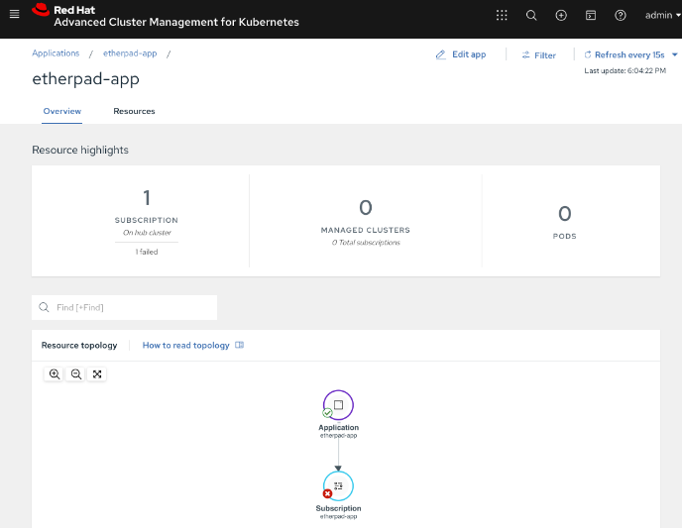

Click the Resources tab to see more information about the resources associated with your application. Note that you now have a Subscription resource and a Channel resource defined and that the Subscription resource is currently Failed.

3. Deploy Application
Now that your application and all of its associated components are created, you are ready to deploy to a target cluster. But you still need to instruct RHACM where to deploy your application and, more specifically, your Subscription resource. The lack of this direction is why your Subscription resource is currently in a Failed state.
- In the RHACM console, click Create placement rule on the right side of the screen and paste the following YAML content into the editor, making sure to overwrite any defaults:
- apiVersion: apps.open-cluster-management.io/v1
- kind: PlacementRule
- metadata:
- name: dev-clusters
- namespace: etherpad
- spec:
- clusterConditions:
- - type: ManagedClusterConditionAvailable
- status: "True"
- clusterSelector:
- matchLabels:
environment: dev
The key:value pair in the clusterSelector section is case-sensitive. Make sure it
matches how you labeled your cluster in the previous lab.
Using the YAML editor in the RHACM console is an alternative way to create resources
related to the application life cycle. It accomplishes the same result as executing the
oc create -f... command, as you did in the previous section.
- Click the Overview tab of your etherpad-app application and observe the topology view being updated after the deployables start rolling out to your target cluster:
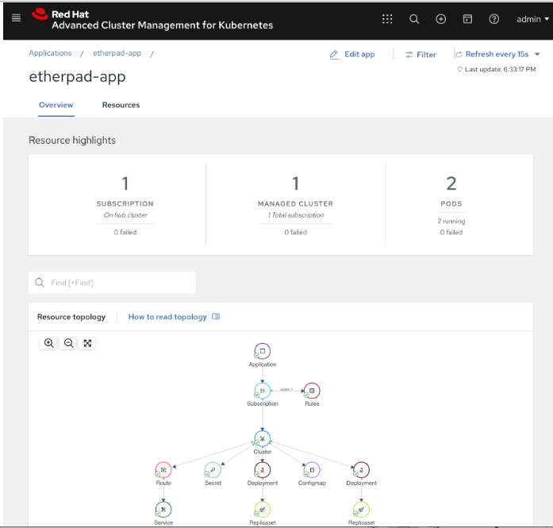

- Verify that your application is deployed by checking the resources in your managed cluster. Run the following command from the bastion VM:
$ oc get pods -n etherpad
Sample Output
NAME READY STATUS RESTARTS AGE
etherpad-5ccc6bdc6d-xj2sg 1/1 Running 0 3m6s
postgresql-7f499d7f94-wdlk9 1/1 Running 0 3m6s
- Find your application’s route, then use it to access the application via a web browser:
$ oc get route etherpad-route -n etherpad -o jsonpath='{.spec.host}'
Sample Output
etherpad-route-etherpad.apps.cluster-acmm1.red.osp.opentlc.com
4. Remove Application
At some point, you will need to remove an application from a cluster. This may be because the application is retired or, in a multi-cluster deployment, it no longer needs to be deployed to a specific cluster or clusters. Fortunately, removing an application from a target cluster is simple. You have two choices.
The first option is to remove the Subscription resource. When you do this, the Subscription resource and the application deployables that were pulled from the Channel resource are removed from the hub cluster. As the change is propagated down to the managed cluster, the Subscription resource and its associated resources are removed. You can see the Pods, Services, Deployments, and other resources being deleted just as if you had logged in and run an oc delete... command. Remember, if you delete the Subscription resource, it affects any cluster it is deployed to based on the PlacementRule resource.
The second option is to remove or modify the PlacementRule resource that the Subscription resource is using to determine target clusters. If you do this, the Subscription resource updates to a new list of target clusters, which in this case is empty, leaving the application nowhere to run. Be careful with this option. If other Subscription resources are using the same PlacementRule resource, you may remove other applications by accident.
In this lab, you remove the Subscription resource.
- On the bastion VM in your hub cluster, verify that you see the Subscription resource for the etherpad-app application. Specifically, observe the metadata/annotations/apps.open-cluster-management.io/deployables and spec sections of the Subscription resource:
  - The deployables list shows you the resources discovered in your repository that deploy to the managed cluster.
  - The spec shows you where this Subscription deploys based on your PlacementRule.
$ oc get subscription etherpad-app -n etherpad -o yaml
Sample Output
apiVersion: apps.open-cluster-management.io/v1
kind: Subscription
metadata:
annotations:
apps.open-cluster-management.io/deployables: etherpad/etherpad-app-resources-etherpad-etherpad-route-route,etherpad/etherpad-app-resources-etherpad-etherpad-service,etherpad/etherpad-app-resources-etherpad-postgresql-deployment,etherpad/etherpad-app-resources-etherpad-ether-secret,etherpad/etherpad-app-resources-etherpad-etherpad-settings-configmap,etherpad/etherpad-app-resources-etherpad-etherpad-deployment
labels:
app: etherpad-app
manager: multicluster-operators-subscription
operation: Update
name: etherpad-app
namespace: etherpad
spec:
channel: etherpad/etherpad-app-latest
placement:
placementRef:
kind: PlacementRule
name: dev-clusters
status:
phase: Propagated
statuses:
my-openshift-cluster:

...<output abridged>...
This annotation lists all of the Deployables found in the Git repository associated with the Subscription.
The spec in your Subscription shows you the Channel and PlacementRules you have previously defined.
- Delete your Subscription resource by running the following command on your hub cluster:
$ oc delete subscription etherpad-app -n etherpad
Sample Output
subscription.apps.open-cluster-management.io "etherpad-app" deleted
- From the bastion VM in your managed cluster, or from the RHACM console, verify that your Subscription resource is gone, along with all of the deployed resources:
$ oc get all -n etherpad
Sample Output
No resources found in etherpad namespace.
- In the RHACM console, navigate to the Overview tab of the etherpad-app application and confirm that only the Application resource remains in the Resource topology section.
- You need the application to be deployed for other labs, so recreate the Subscription resource. You can do this via the CLI or by navigating to the Resources tab for the etherpad-app application in the RHACM console and clicking Subscription on the right side of the screen. Use the following YAML content:
- apiVersion: apps.open-cluster-management.io/v1
- kind: Subscription
- metadata:
- name: etherpad-app
- namespace: etherpad
- labels:
- app: etherpad-app
- annotations:
- apps.open-cluster-management.io/github-path: resources/etherpad
- spec:
- channel: etherpad/etherpad-app-latest
- placement:
- placementRef:
- kind: PlacementRule
name: dev-clusters
If you use the RHACM console, replace everything in the YAML editor with the content above.
  - After a few minutes, expect to see your application redeploy to the target cluster.
5. Change Deployed Application (Optional)
What happens if you need to update an application that is already deployed? Making changes directly on the target cluster results in a system that is out of sync (worst case) or changes that get overwritten and reverted back to their original values defined by the deployables from the Channel resource. The appropriate method is to make changes to the manifests stored in your repository. Once those changes are made, you commit and push them to the Git repository. From there, let RHACM take over and make sure they get deployed.
This exercise is optional.
- In the local clone of your forked GitHub repository, create a new file that defines a persistent volume claim (PVC) for your database and save the file as $HOME/rhacm-labs/resources/etherpad/postgres_pvc.yaml:
- apiVersion: v1
- kind: PersistentVolumeClaim
- metadata:
- labels:
- template: postgresql-persistent-template
- name: postgresql
- spec:
- accessModes:
- - ReadWriteOnce
- resources:
- requests:
storage: 2Gi
- You have defined a PVC to use, but now you need to update the Deployment manifest for PostgreSQL. Edit the $HOME/rhacm-labs/resources/etherpad/postgres_deployment.yaml file, replacing the existing postgresql-data volume with the following content:
You can find this section at the very end of the file.
- ...
- volumes:
- - name: postgresql-data
- persistentVolumeClaim:
- claimName: postgresql
- Save the file.
- Commit and push both of your changes to your GitHub repository:
- $ cd $HOME/rhacm-labs
- $ git add resources/etherpad/postgres_pvc.yaml resources/etherpad/postgres_deployment.yaml
- $ git commit -m 'update postgres pvc and deployment'
$ git push origin master
- On the bastion VM in your managed cluster, check on your Pods. Note that after a minute or so, the postgresql Pod moves into a Terminating state because the Deployment resource was updated, and a new Pod starts using the PVC you provisioned.
$ oc get pod,pvc -n etherpad
Sample Output
NAME READY STATUS RESTARTS AGE
pod/etherpad-5ccc6bdc6d-xr8nw 1/1 Running 2 67m
pod/postgresql-6df558f94c-djbvp 1/1 Running 0 5m42s

NAME STATUS VOLUME CAPACITY ACCESS MODES STORAGECLASS AGE
persistentvolumeclaim/postgresql Bound pvc-f4ccd5b8-e9ce-4348-a32b-ad38192fc697 10Gi RWO standard 21m
- Optionally, you can watch for the new resources in the RHACM console.
  - Expect to see the new PVC resource appear in the topology view. The deployables for both the PVC resource and the PostgreSQL Deployment resource are updated.
You have now employed a GitOps approach to deploying and updating an application. By storing your configuration in a Git repository, you were able to make changes to it simply by pushing a small change.

